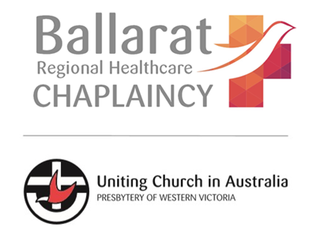
Chaplaincy and
COVID-19 Guidelines
(updated July 10th 2020)

Until August 19th, 2020, metro Melbourne and Mitchell Shire are in lock-down due to the spread of Coronavirus (COVID-19). Ballarat remains exempt from this lock-down and the previous restrictions still stand. The following are guidelines recommended by Ballarat Regional Healthcare Chaplaincy ministry. They may also be appropriate for your local context also if you are in other parts of regional and rural Victoria.

What does this mean for Chaplaincy programs and volunteers?
- Regular pastoral visiting through the Assistant Chaplains program remains suspended.
- Regular monthly Church Services in Aged Care and Specialised Care venues remain suspended.

Can I still visit people in hospital?
- Ballarat Base Hospital and St. John of God Hospital Ballarat both require patients to nominate a designated visitor for the duration of their stay.
- If you are NOT the designated visitor, you cannot visit people in hospital.
- If you are aware of a church member in hospital who you feel may need pastoral support, please contact Andrew.

Can I still visit people in Aged Care?
- Similar to hospitals, Aged Care venues have protocols around who can visit and for how long. In short, you may be allowed to visit if you book ahead.
- In many cases, the Venue will ask you to call ahead to make a booking. You will likely need to call the day (or a few days) before you wish to visit.
- You may have a limited time (eg. 30 minutes, 60 minutes)
- You may not be allowed to visit if the resident has already had another visitor that day
- You will not be allowed to visit other residents while you are visiting the Venue
- If you are aware of a church member in Aged Care who you feel may need pastoral support, please contact Andrew.

Can I visit a person in Aged Care as their Chaplain or Pastoral Support person?
The DHS website acknowledges people in Aged Care may require a support person to visit. https://www.dhhs.vic.gov.au/visiting-care-facilities-covid-19#who-can-visit
If you would like to provide a pastoral visit to a person you regularly see, BRHC suggests that you:
- Contact the Venue first to ascertain it is safe and appropriate to visit that person
- Make a booking as per Venue protocols
- Follow all other guidelines as per Venue timing, hygiene etc.
- Contact Andrew to let him know your intention to visit/have visited

What is Chaplaincy (BRHC) doing to provide support during Coronavirus restrictions?
- BRHC is developing a range of online resources available for church groups, aged care residents, hospital patients and people who need some support during this time. These can be accessed through the BRHC YouTube channel: https://www.youtube.com/channel/UCei1wxWQZXWOtnzN9lJEROQ/videos?view_as=subscriber
- Chaplaincy has been developing connection through other social media platforms including Facebook, Twitter & Instagram.
- Andrew remains On Call for End-of-Life, palliative and other significant pastoral needs

And finally…

- Follow all the usual directions from government and health authorities.
- Maintain good hygiene and social distancing practices
- Be aware of your own health and well-being levels
- Contact Andrew for any healthcare pastoral concerns
